**Peabody Police V.I.P.S. Newsletter**

SPECIAL EDITION DECEMBER 7, 2016

**Travis Smith, VIPS Volunteer, Editor**

**Our Best Wishes For A**

**“Happy Retirement” To**

**Our Great Friend & Leader**

**Lieutenant Sheila McDaid**



ABOUT LT. SHEILA McDAID 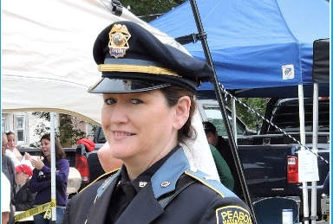

 By Judy Selesnick

Lieutenant Sheila McDaid has achieved a lot of “firsts” in the Peabody Police Department. She is currently the highest ranking female police officer in Peabody, having begun her official police career in 1989 when she and Nancy Hart were sworn in together as the first female Peabody police officers. In1994, Sheila was promoted to the position of first female detective in the City, and in 1998 was also sworn in as the first female Police Sergeant in the City of Peabody, and then, in 2015, she was sworn in as the first female Police Lieutenant in the department.

Currently, she heads the Records Department. Previously, for 12 years, Lieutenant McDaid headed the Domestic Violence/Sexual Assault Unit, coordinated the RAD self-defense program for women and children, and was also the coordinator and contact person for the Sex Offender Registry. She also supervised the School Liaison, JV & DARE officers, and detectives. In addition, she has worked “stints” as Watch Commander, Court Prosecutor, Patrol Supervisor, and as the Director of the VIPS (Volunteers in Police Service) program since its inception.

In her “spare time”, Lieutenant McDaid has also been an instructor at the Municipal Police Training Committee, (formerly the Massachusetts Criminal Justice Training Council), in the areas of sexual harassment, domestic violence, and Child and Elder abuse. She has also taught at many area reserve police academies, the Essex County Sheriff’s Department Academy, and continues her position as an Adjunct Instructor at North Shore Community College.

Article continues on page #2

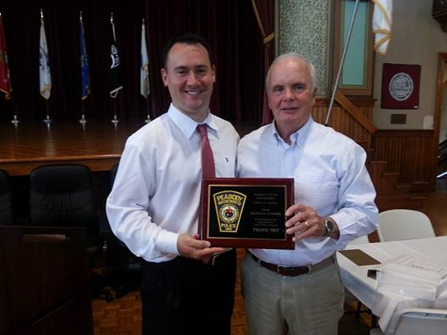





Some Previous Volunteer Sports

**Peabody Police V.I.P.S. Newsletter – Page 2**

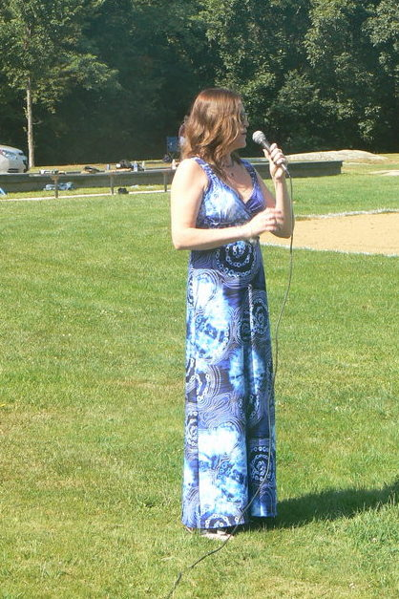

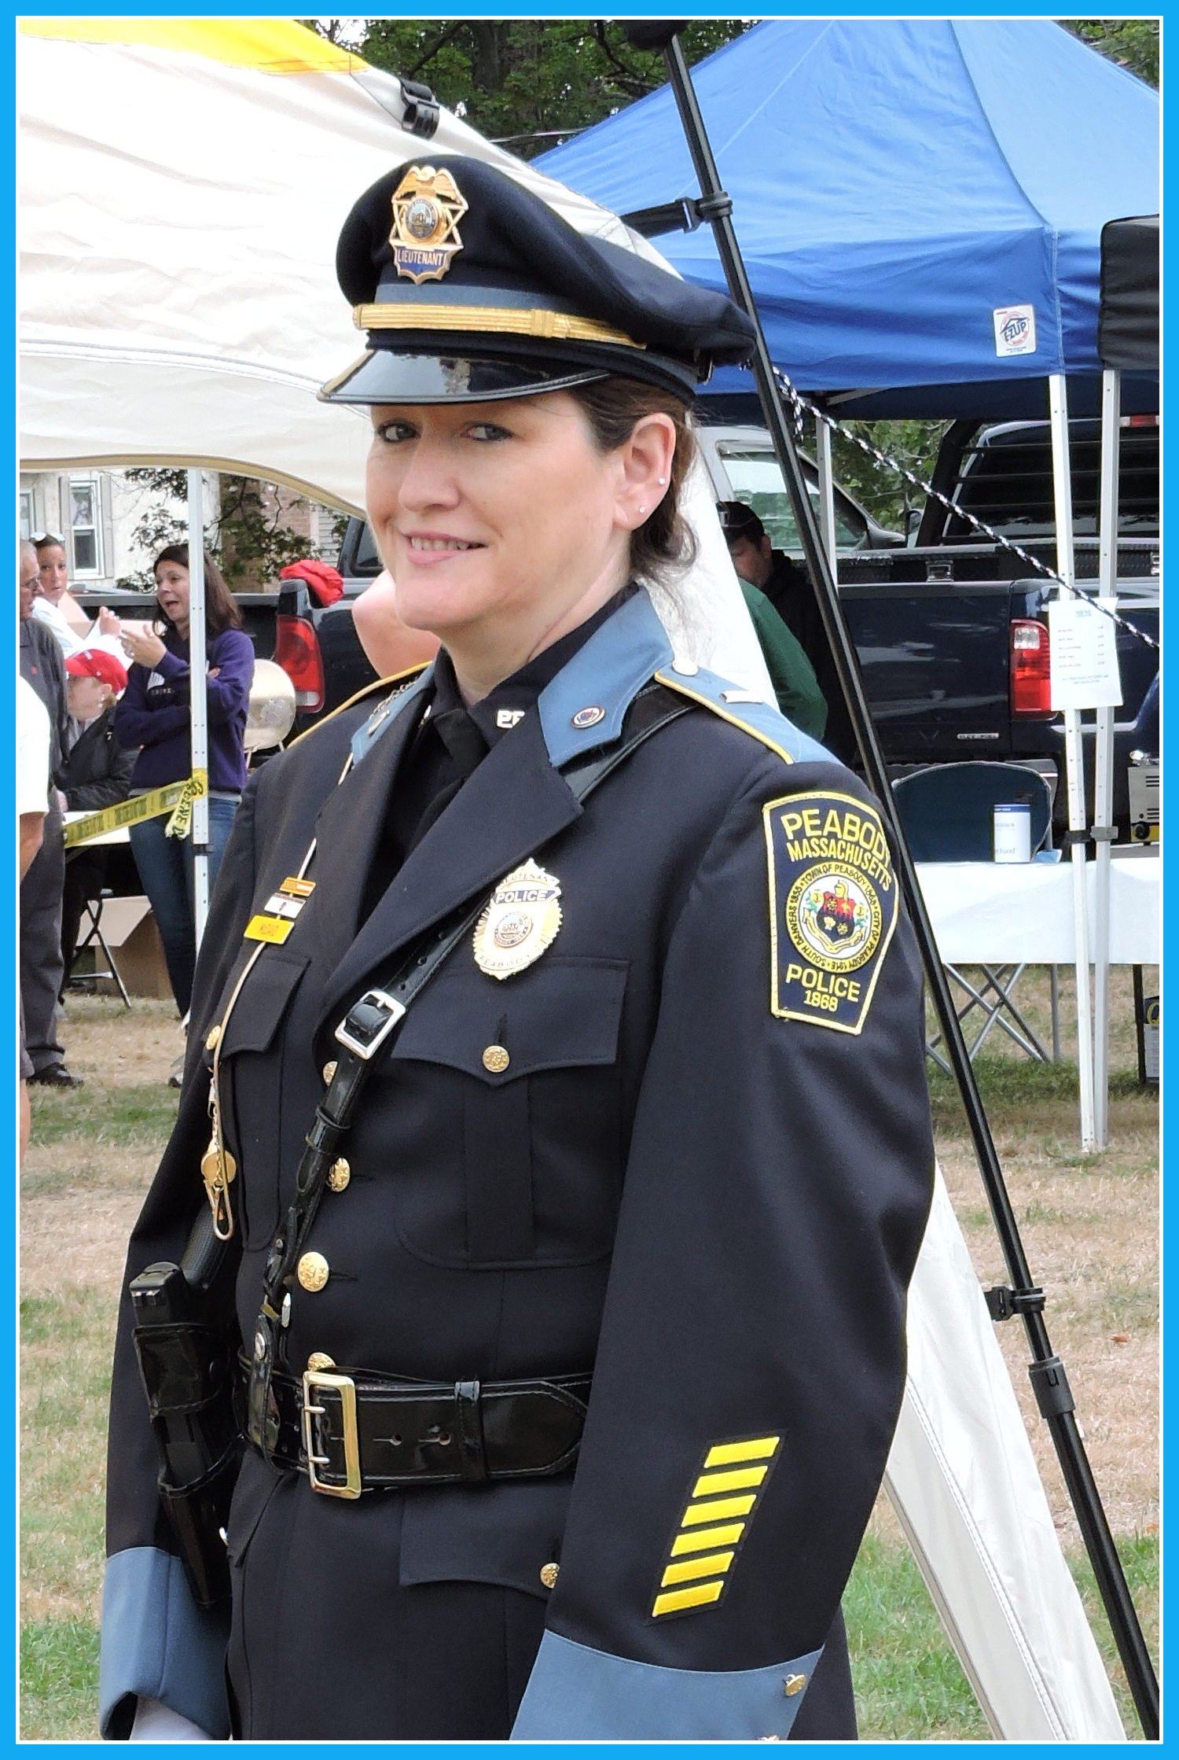

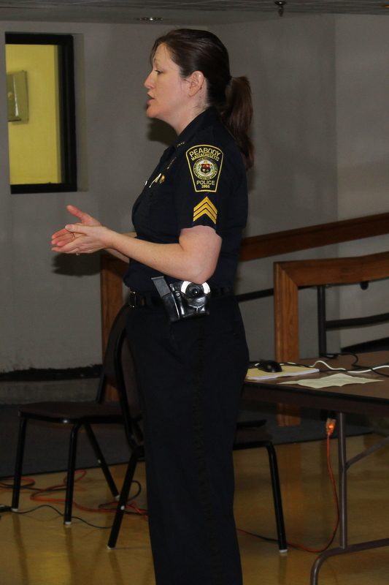

About, cont.

The Peabody VIPS members thank Lt. Sheila McDaid for organizing, developing, and leading this innovative Citizens’ program, since its inception. We have learned a lot over the past several years, been awarded a MEMA/FEMA grant, passed the FEMA testing, and developed a unique working relationship with the Peabody Police Department and other municipal groups.

We all wish Lt. McDaid (Sheila) – who is also a very devoted daughter, mother, sister, grandmother, and friend – the best of luck in her retirement. We will very much miss her leadership and devotion to the PPD and the VIPS!

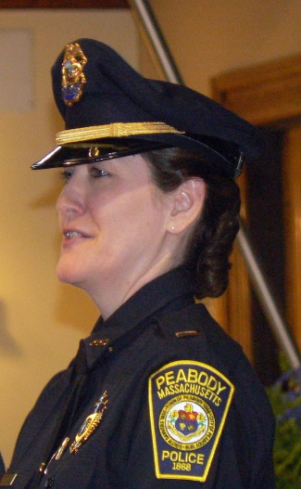

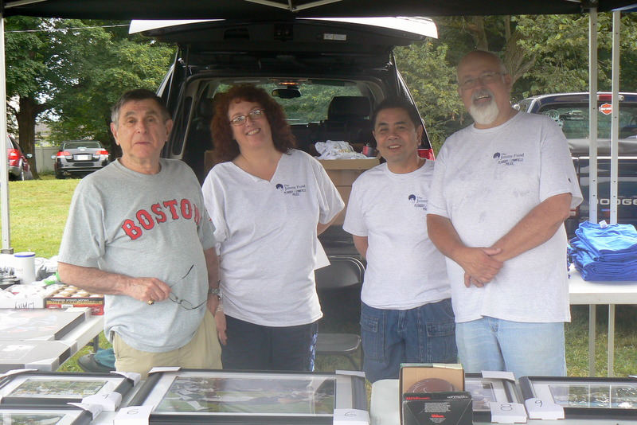

I would also like to thank Sheila for all her help with the VIPS Newsletters, as well as with the over 4.300 Survey letters which have been sent out over the last years. I know we will all miss her assistance in all our endeavors, and especially her infectious laugh. We all wish her the best of luck with her new career in photography!

Travis Smith

VIPS Volunteer





*This page is intentionally left blank*