**Peabody Police V.I.P.S. Newsletter**

Volume 3, Issue 2 (whole #10) April 1, 2015…













**23rd Anniversary Event!**



 





C:\Program Files\Microsoft Office\MEDIA\OFFICE14\Lines\BD21322_.gif

Travis Smith, Nino DeLaCruz,

VIPS Volunteer, Editor Peabody Police Photos

C:\Program Files\Microsoft Office\MEDIA\OFFICE14\Lines\BD21322_.gif

This Month’s Issue Will Feature Information on the HAWC Organization As well As Other Activities of the VIPS Volunteers and the Peabody Police Department

The walk for HAWC (Healing Abuse/Working for Change) was brought to our attention by Lieutenant Sheila McDaid, who is the Team Recruitment Chairperson for the 2015 Walk Committee. This organization addresses issues of domestic abuse, and was founded in 1978. After existing for 30 years as “Help for Abused Women and their Children”, it changed its name to “Healing Abuse Working for Change”, in order to better represent its commitment to serve all persons affected by domestic abuse. Today, after 35 years in business, HWAC has a staff of 22, and a base of volunteers of over 50. The organization serves 23 cities and towns on the North Shore, and has 5 locations in the area, including Salem, Beverly, Gloucester and Lynn, where people can seek many comprehensive services. The area of Domestic Abuse can include many tactics, such as cultural abuse, physical abuse, and mental/emotional abuse. All of these and more are covered by HAWC, thru their 24-hour hotline, support groups, children’s services, and many other programs. If you wish to register online for the walk, or donate to the organization, the web site is: www.hawcdv.org/give/walk-for-hawc/

**THE HAWC HOTLINE NUMBER: 1-800-547-1649**

The WALK for HAWC will be held on Sunday, April 26, 2015.

The WALK will begin at the Salem Common at noon.

Registration will be open at 9am and close at 11:55 am.

The event is free of charge, but requires a $10 fee for walk

T-shirts.

C:\Users\205\AppData\Local\Microsoft\Windows\Temporary Internet Files\Content.IE5\VGRBO2RU\page-divider2[1].gifC:\Users\205\AppData\Local\Microsoft\Windows\Temporary Internet Files\Content.IE5\VGRBO2RU\page-divider2[1].gifC:\Users\205\AppData\Local\Microsoft\Windows\Temporary Internet Files\Content.IE5\VGRBO2RU\page-divider2[1].gif

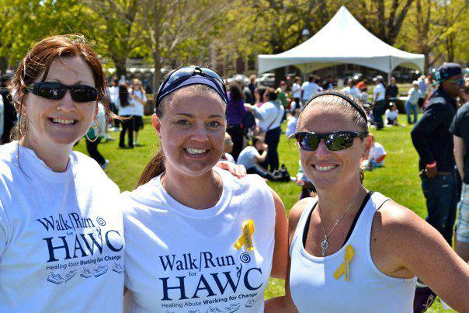

*Lieutenant Sheila McDaid, Detective Stephanie Lane, and Officer Taryn Brotherton, at a previous walk ~*

**Peabody Police V.I.P.S. Newsletter – Page 2**

**Firefighter Rice Memorial 5K**

On Saturday, April 11, 2015, the fourth annual race to honor Firefighter Jim Rice will be held.

All proceeds will benefit the Peabody Fire and Police Memorial Fund. The Memorial fund is to raise money for a memorial park to be built at the corner of Perkins Street and Ellsworth Street in Peabody, (covered in a previous issue of this newsletter).

Race Location: AOH Club, 58 Lowell Street, Peabody, MA.

Race Time: 9AM

Race Fee: $25.00

Awards: Top M and F Overall, and Top 3 M/F in the following age groups: 18 and under, 19-29, 30-39, 49-49, 50-59, 60-69, and 70+

Raffles will take place after the race at the AOH club.

For more info on the Peabody Memorial Fund please go to:

[www.peabodymemorial.org](http://www.peabodymemorial.org)

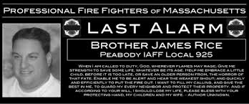

Please give to the:

***Peabody memorial fund***

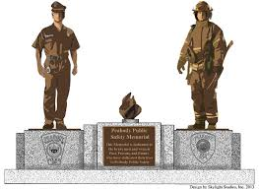





Some Previous Volunteer Sports

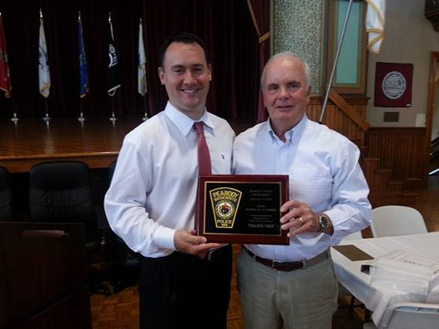



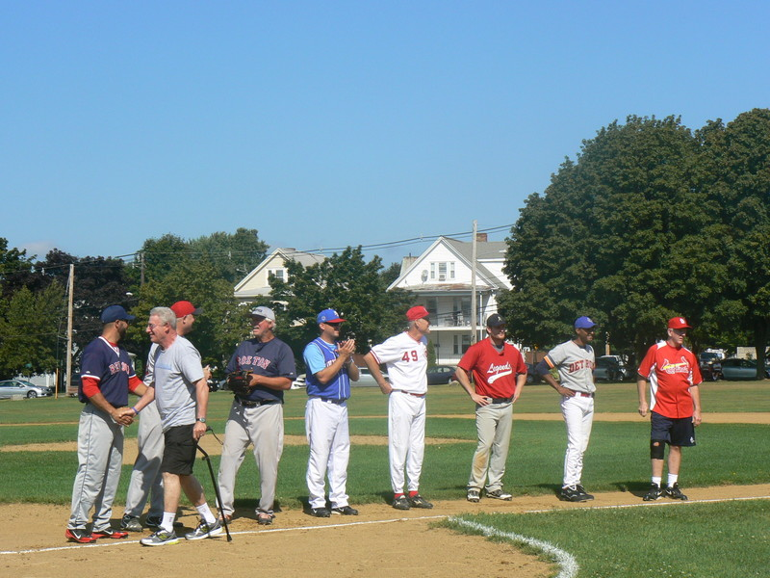



**Hope you had a Merry Christmas**



**Peabody Police V.I.P.S. Newsletter – Page 3**

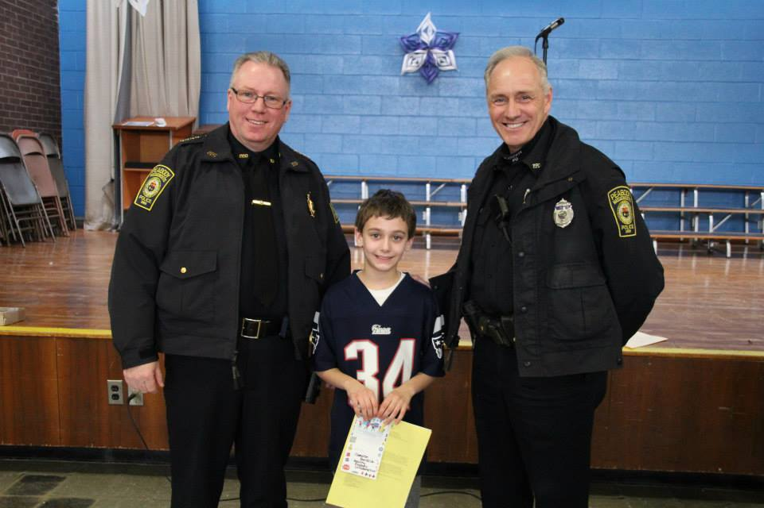

Chief Thomas Griffin and Officer Rich Cochran With Burke School Student “Cameron”

C:\Program Files\Microsoft Office\MEDIA\OFFICE14\Lines\BD21332_.gif

Chief Griffin attended “Red Ribbon Week” at the Burke School recently, and awarded a special prize to this student for his excellent essay on what he wants to be when he grows up, and why.

The student wrote that he wanted to be the Chief of Police.

C:\Program Files\Microsoft Office\MEDIA\OFFICE14\Lines\BD21332_.gif

Touring the cell area with

Officer Cochran

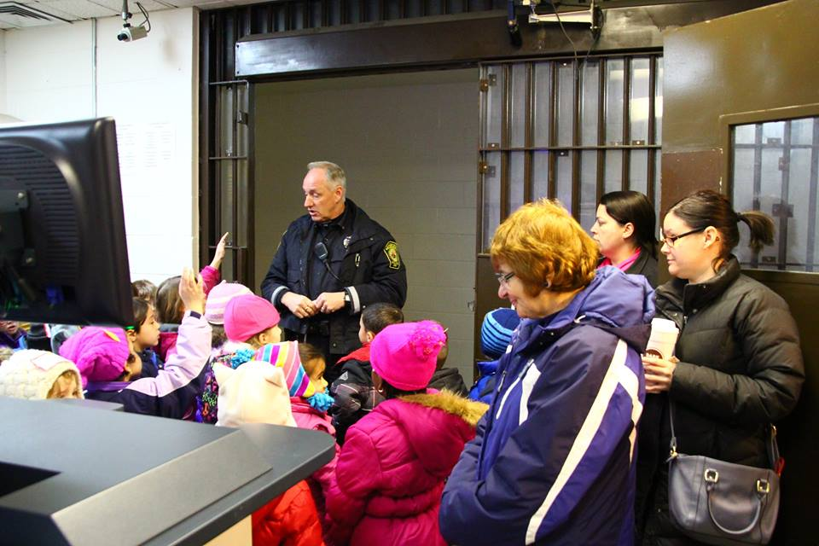

Tour of the Police Garage to see the vehicles

In the Chief’s Office with Chief Thomas Griffin

Carroll School Students and Staff visited the Peabody Police Station, and were given a tour of the facilities. They are pictured here with Chief Griffin, McGruff the Crime Dog, Sergeant Rich Girolimon and Officer Brendan O’Brien.

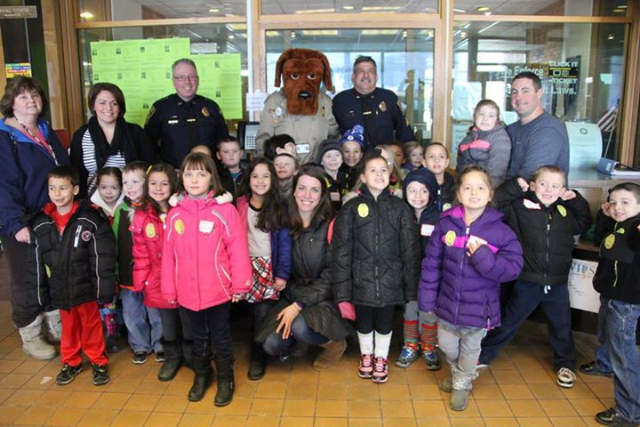

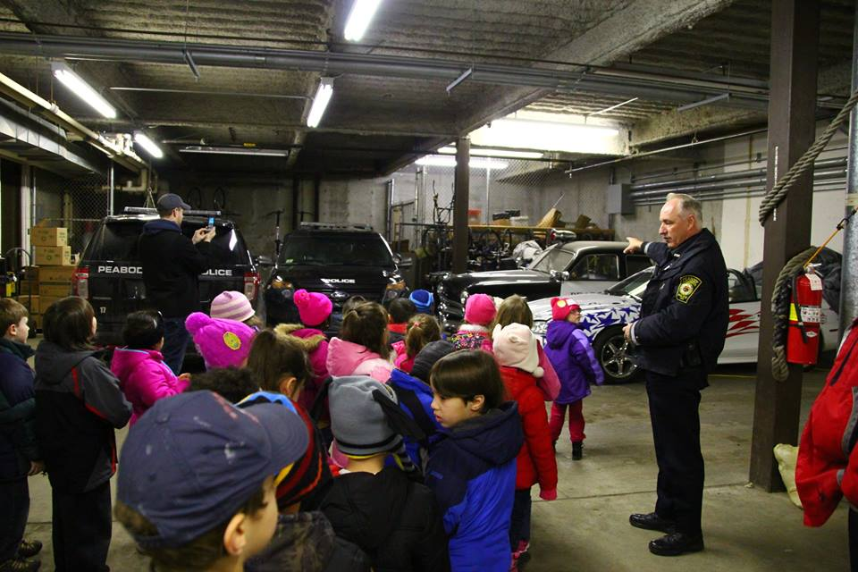

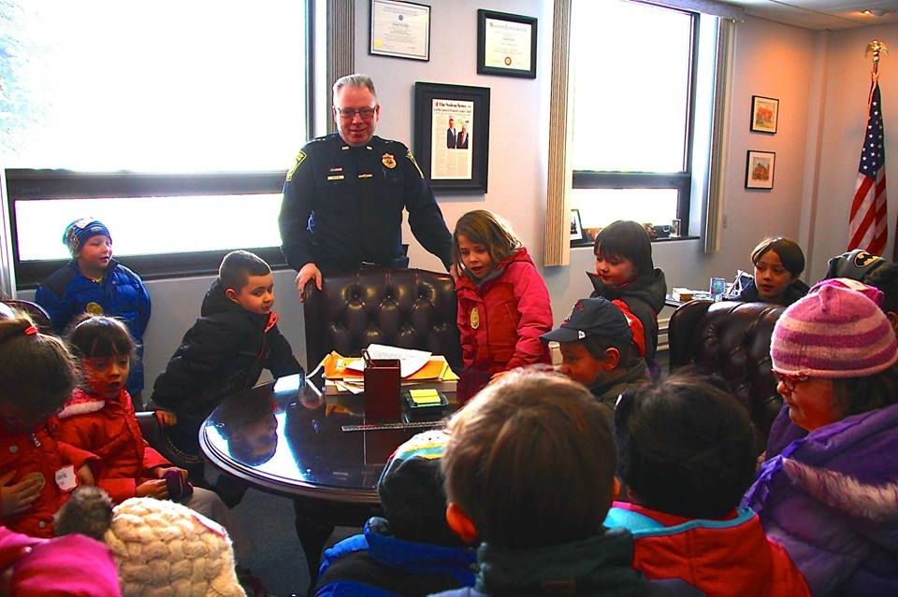



*M*

***“Volunteers are not paid --- not because they are worthless, but because they are priceless”***

***~ Sherry Anderson***